**26.AWS-Redshift**

This is not regular data base. The redshift is mainly used for data processing

You cannot shutdown redshift like EC2 either you can delete or reboot.

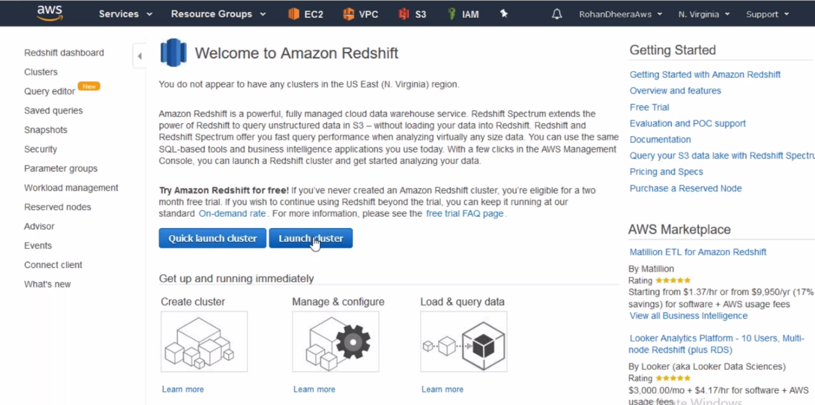

--- go the clusters and launch clusters.

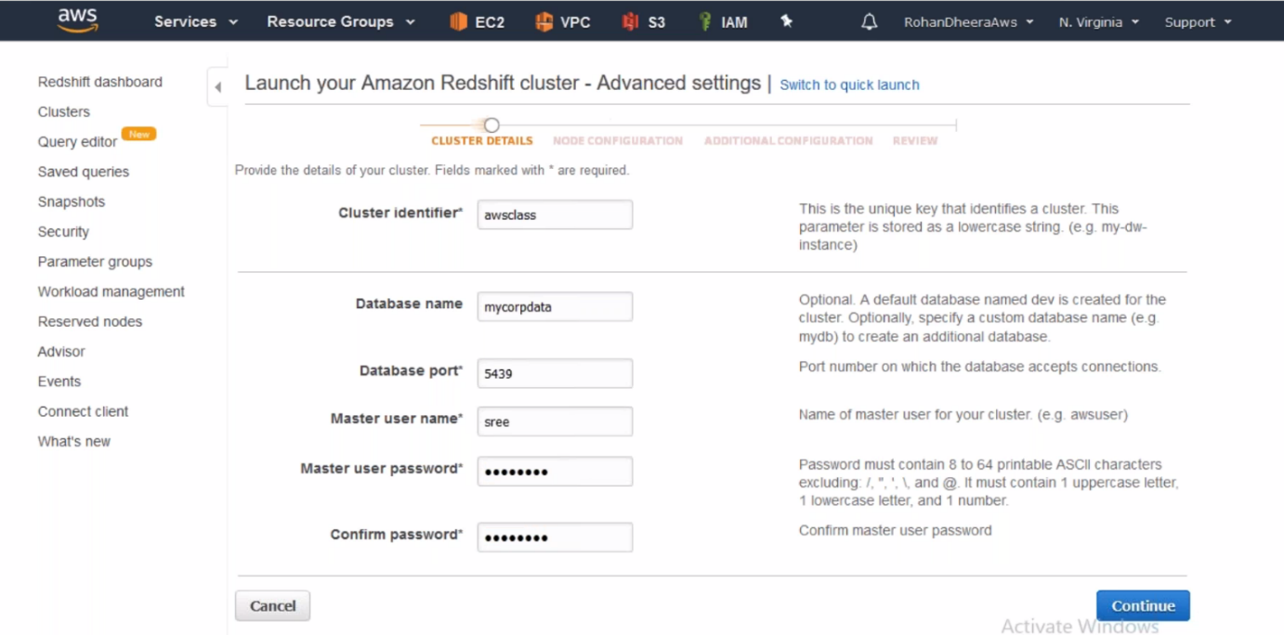

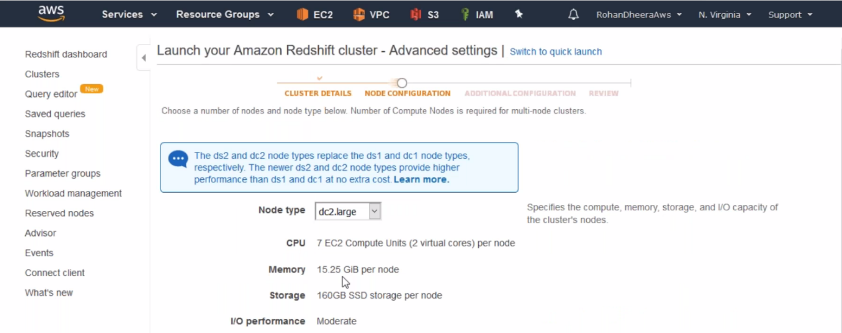

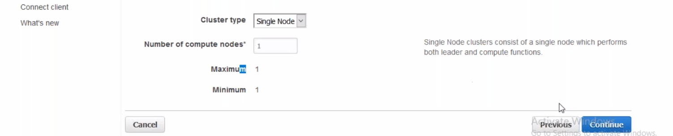

--- same like data base we need to create subnet groups here.

**Subnet group creating**

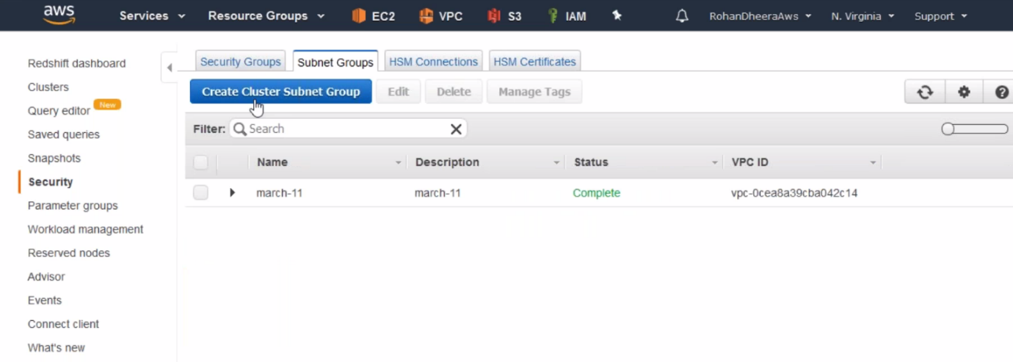

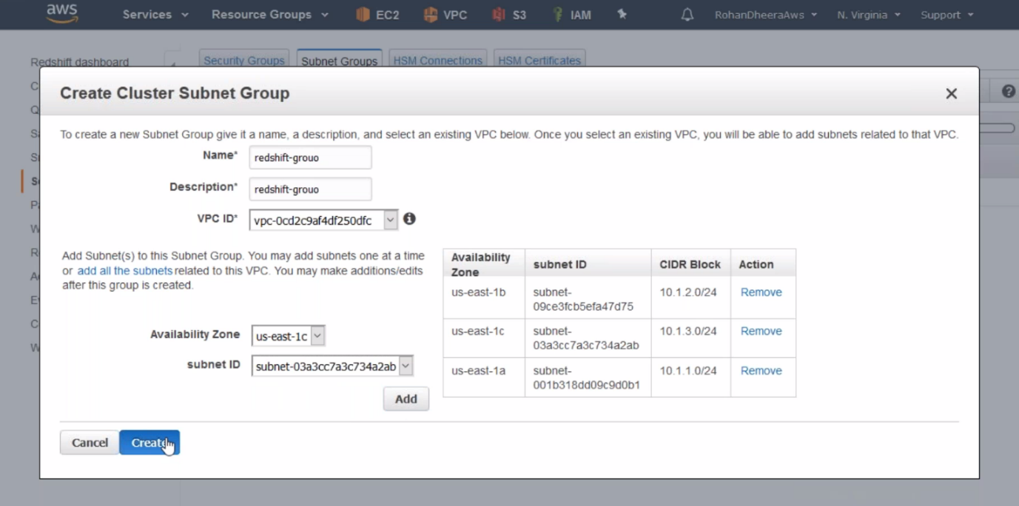

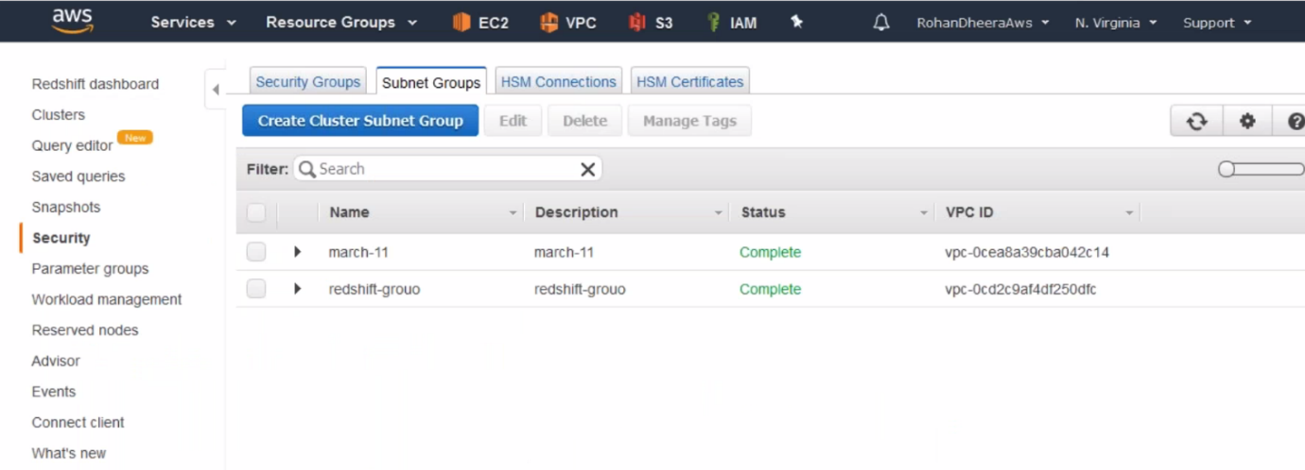

**Over**

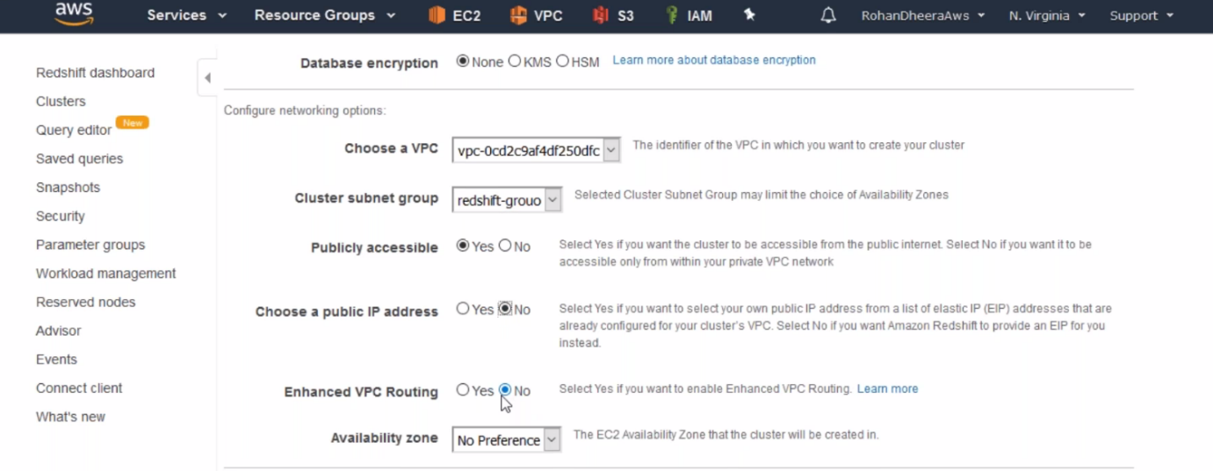

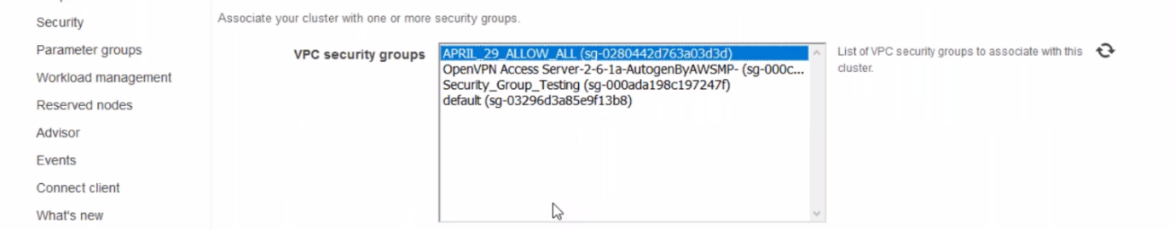

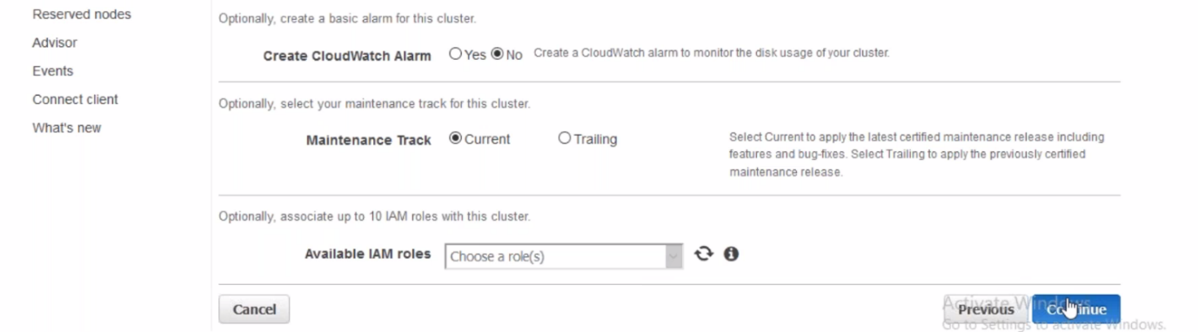

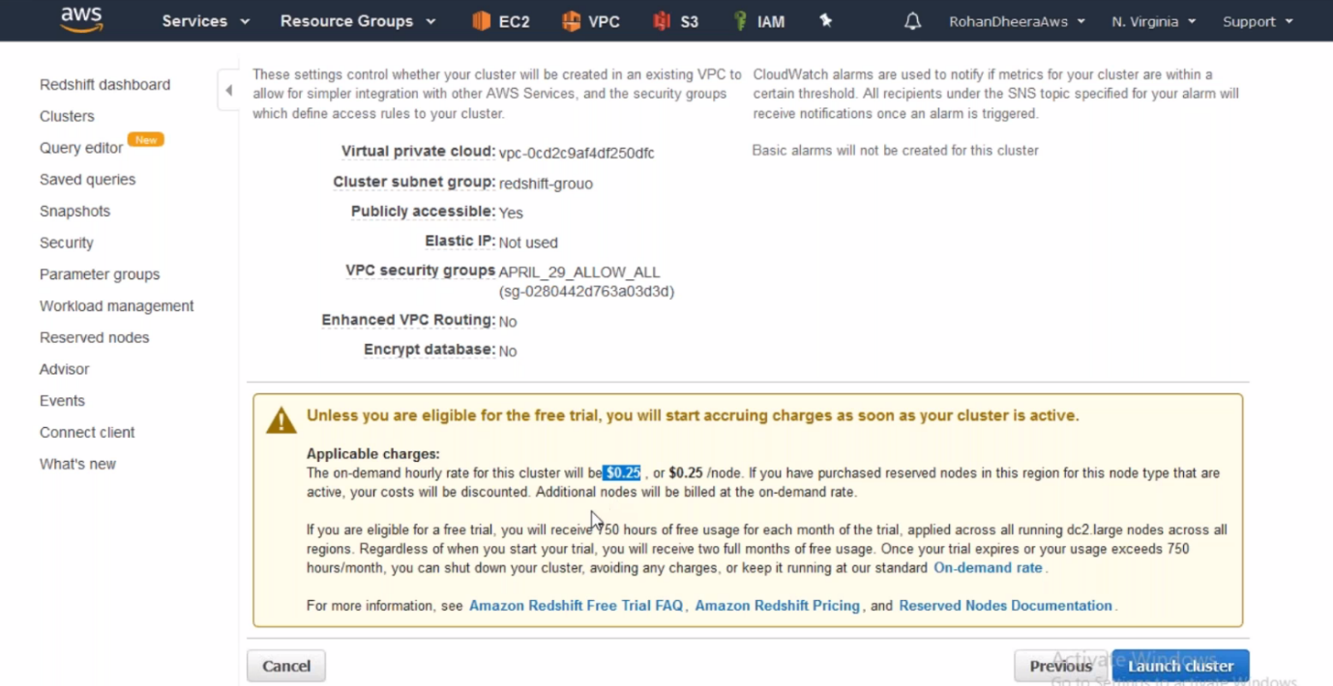

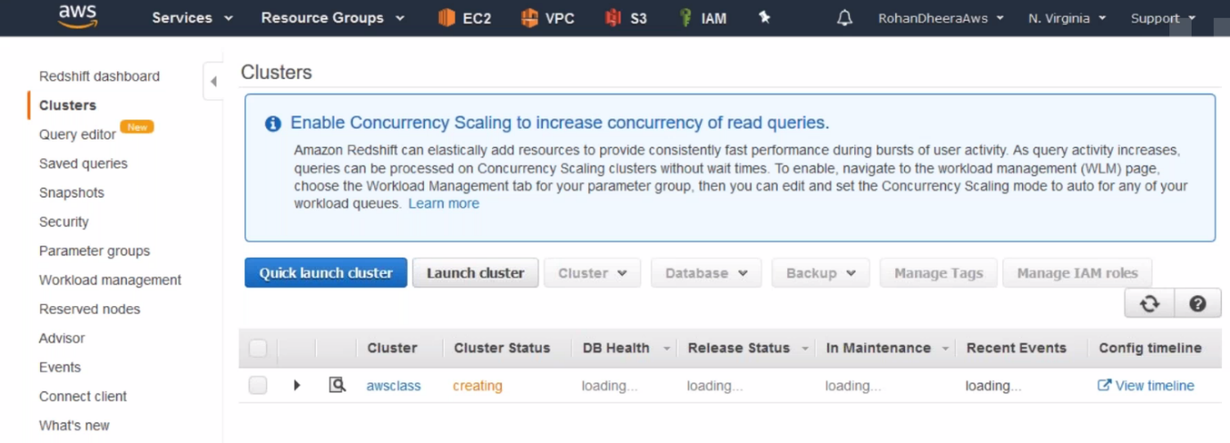

--- now the Redshift is created.

**Connecting to Redshift**

In MYSQL DB we have downloaded MYSQL work bench for connecting MYSQL DB. Same as MYSQL DB here also we will download work bench for connecting Redshift.

You need to install opn-jdk to run this work bench.

--- redshift test data – they will provide some data for testing.

--- create access and secret key.

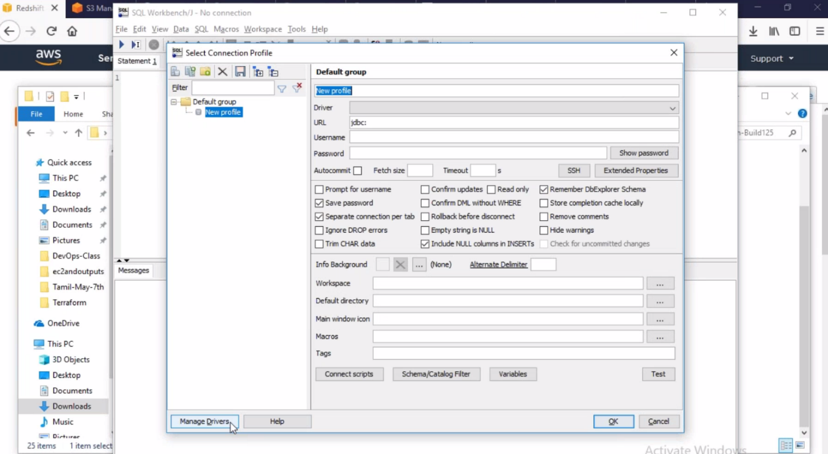

--- this work bench is won’t work unless we uploaded redshift JDBC 4.2.JAR Driver.

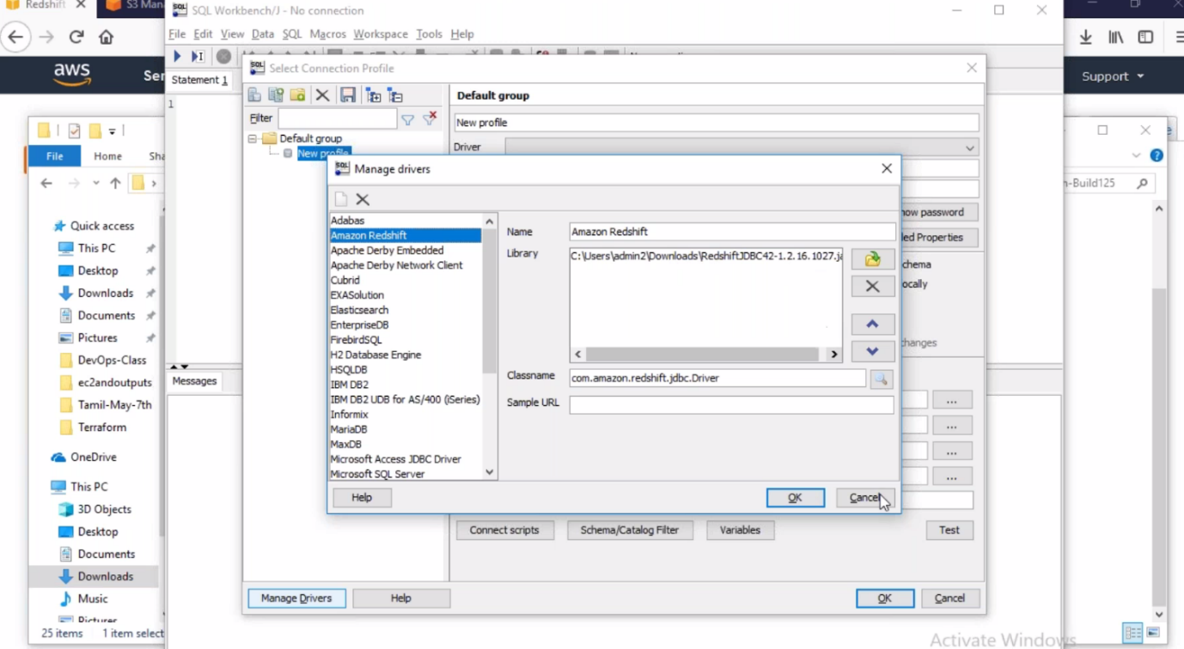

--- click on ok.

**Load the driver**

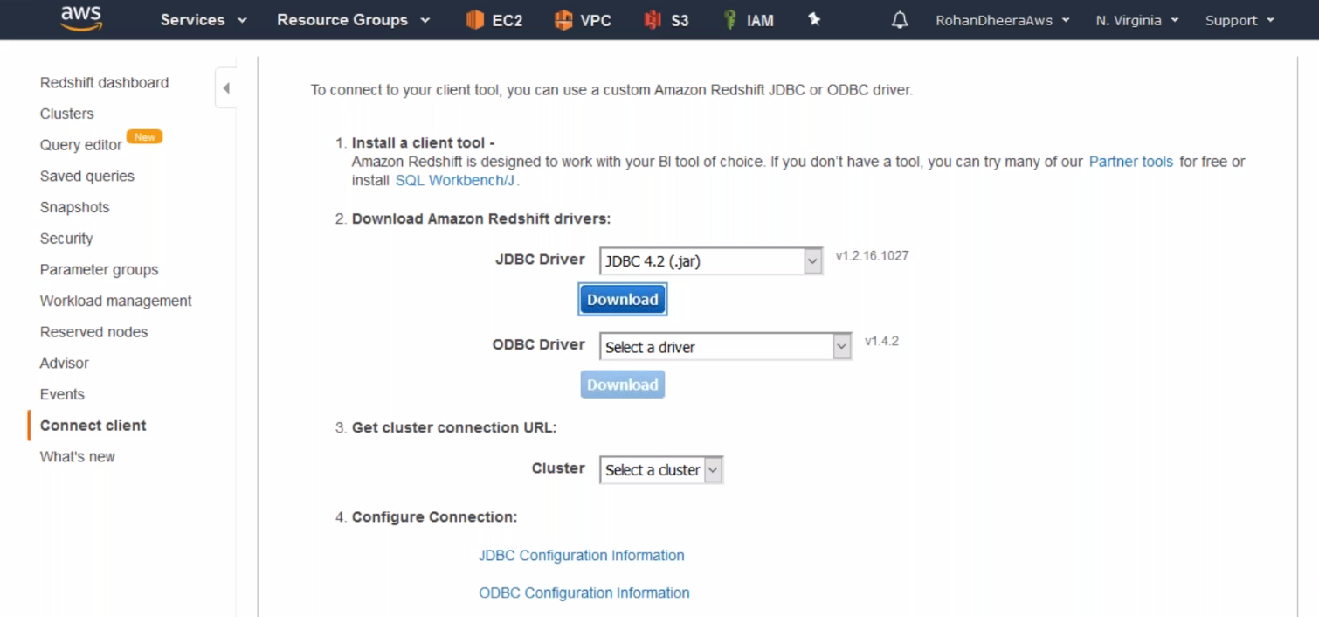

--- download the driver and load it in work bench

**Connecting**

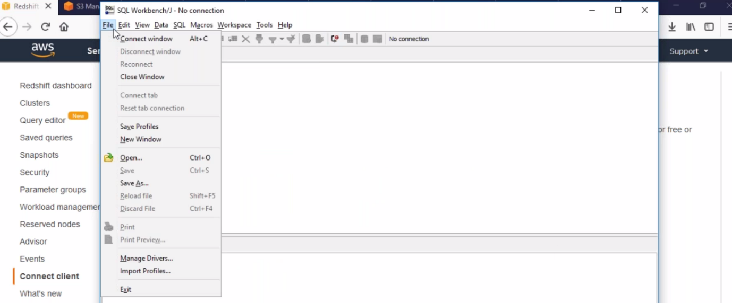

--- click on connect window.

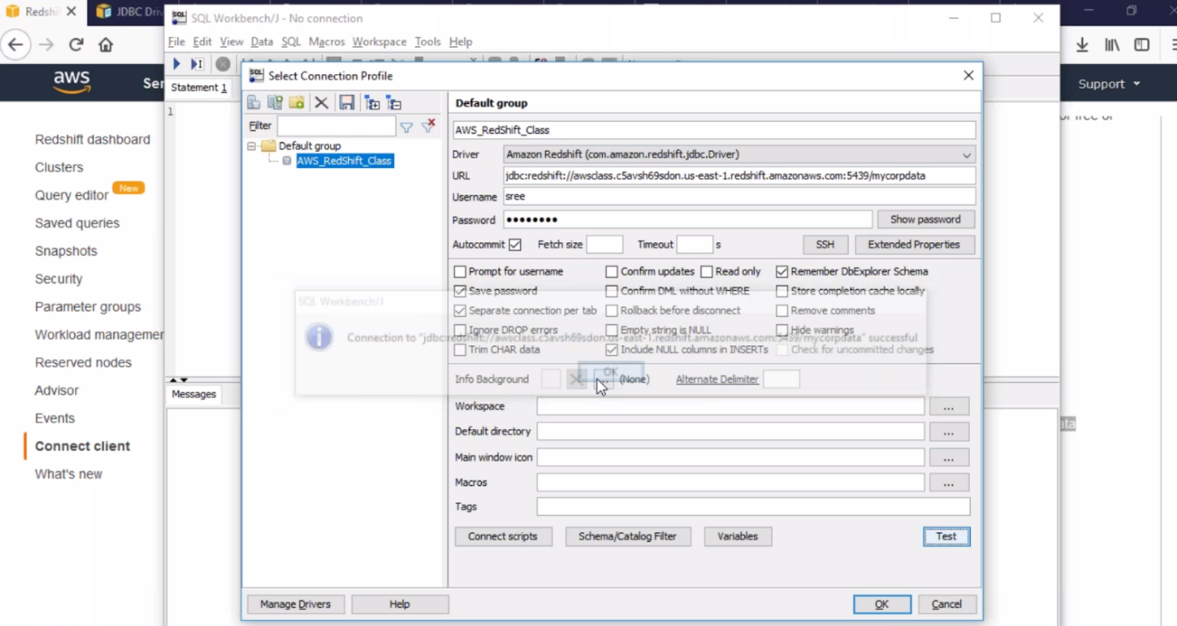

--- copy the URL from below process.

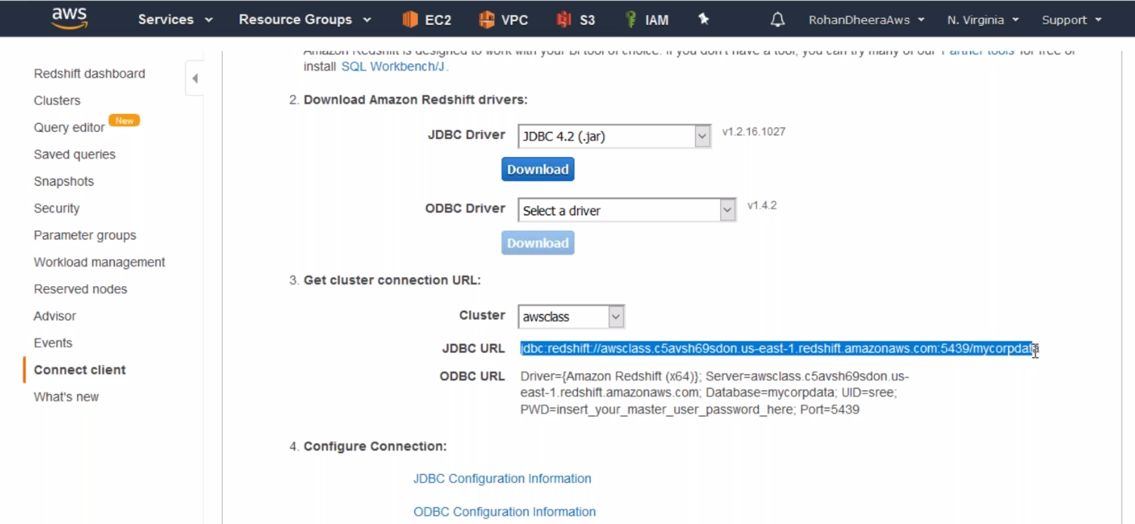

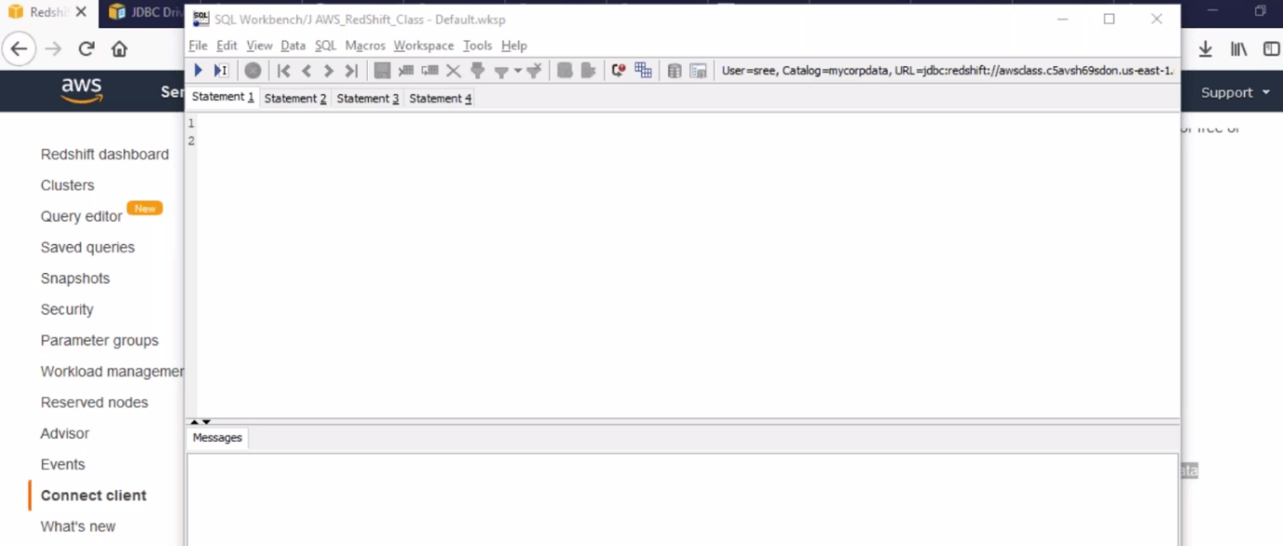

--- by default there will be no data.